# VBCS CUSTOMER ONBOARDING SCREEN

This VBCS screen is refer to the to review existing staffing customers or create new customers with respect to staffing orders.

* Staffing Accountant able to view existing orders and customers first and if not found then able to onboard new customers.
* Staffing accountant can view the customer details using either customer name and PO number or by giving both customer name and PO number and search.
* Staffing accountant can view the below information if a customer with PO details exists.
  + PO (Staffing Order) number
  + Customer Name
  + Customer Number
  + Customer Address
  + Customer Bill to Site
* One customer can have multiple PO associated with it.
* PO number can be alphanumeric.
* PO number should be appended with the word SO-
* PO number will be the actual PO number provided by the customer on their PO document.
* In case no reference to the matching customer is found then the staffing accountant can click on **Download** button and download the customer template to create a customer screen.
* Input the required information into the Excel document, then convert to a CSV format and compress it into a ZIP file.
* Used the **Upload** button to submit the zipped file, and wait for some time. Once the customer is uploaded successfully then successful notification will be display on screen.

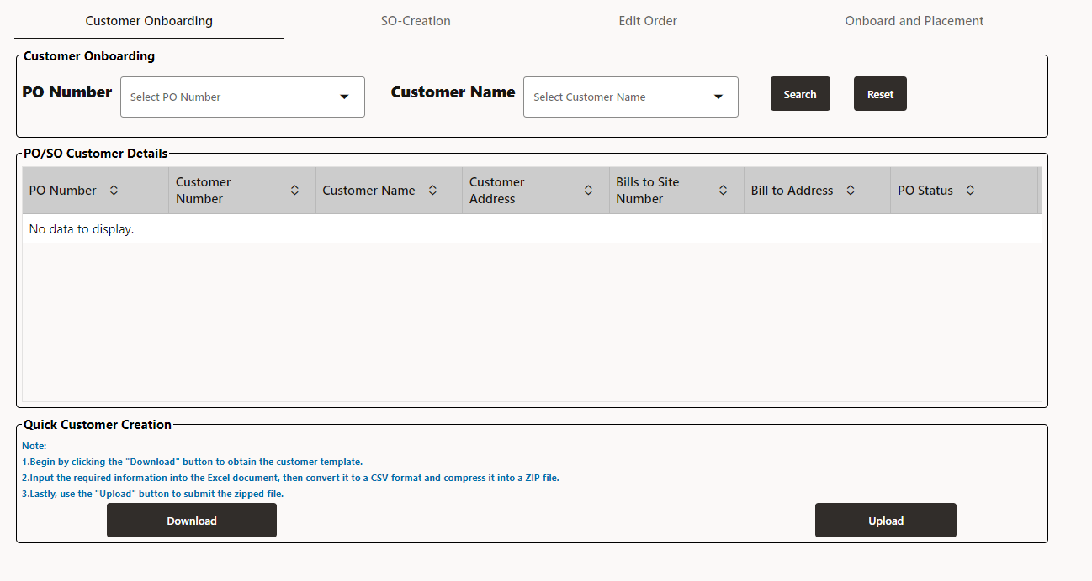

# SO-Submit and Placement Integration Process.

This document is to refer the Integration details which used to create project and Contract in SaaS from VBCS Screen.

## Customer Onboarding Integration:

**XXCG Staffing Get Customer**: This Integration is used to get customer details from SaaS. It is used in VBCS to fetch the Customer Details in Customer Onboarding Screen.

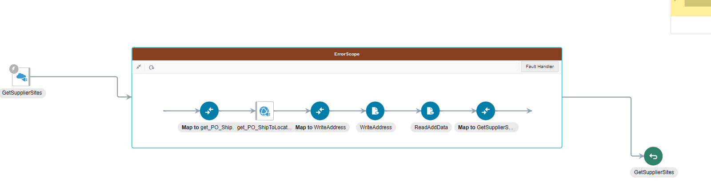

**XXCG Staffing Customer Spreadsheet Upload FBDI:** This Integration is used to load customers from Spreadsheet.

Integration will get the file from VBCS('aruploadcustomers.zip’) and Load it into SaaS By using Upload Customers Import process .Once loaded we need to get the status of the ESS Job If ESS Job is success then again we need to submit ESS Job from SOAP Call.

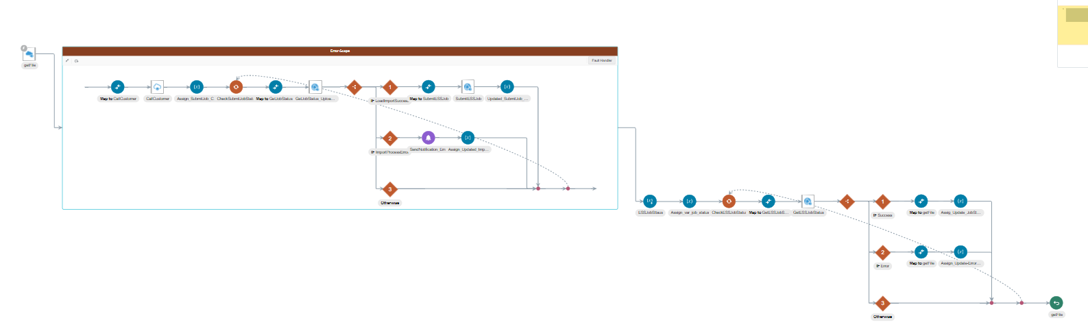

If it succeeded, Check it SaaS whether customers were uploaded successfully or not. if Failed check the logs for reason.

## SO -Creation Project Submission & Placement

In This section, there are multiple integrations involved.

* Project and Tasks Creation
* Project Costing Creation when Person Name available in Request Payload
* Project Team member Creation.
* Expenditure Type Creation Based on the Pay Rates provided in Payload.
* Project Costing Creation FBDI Process.

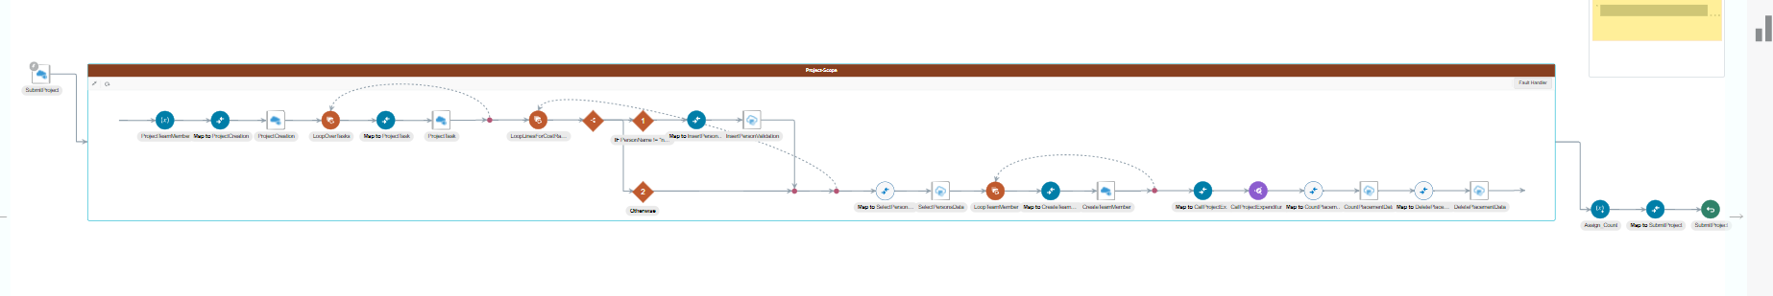

**XXCG Staffing Project Creation:** This is the parent integration which is calling from VBCS screen to process the data to create project and Contract.

In This integration, Project and Tasks will create along with the Team member if person Name is available. if not only project and tasks will create in SaaS.

If person Name is available, then it will create project Expenditure Type and call below child integration to create project Expenditure.

**XXCG Staffing Project Expenditure Creation:** This integration is used to create project Expenditure Type based on the pay rates provided in Payloads.

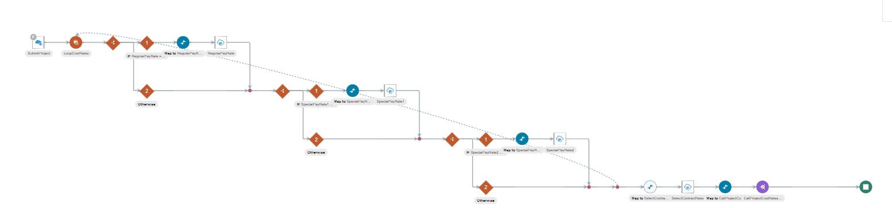

**XXCG Staffing Project Cost Rate Overrides FBDI :** This is the child integration **of XXCG Staffing Project Expenditure Creation** integration ,based on the Expenditure Type created **,Data will fetch by this integration and load the data in SaaS by FBDI Process.**

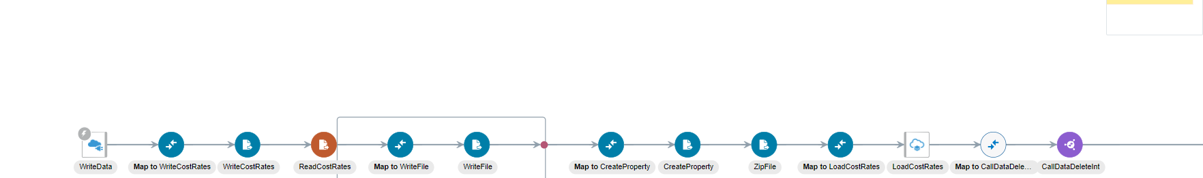

Once data successfully loaded into SaaS It will call child integration to clear the data from ATP tables**.**

## SO-Creation Contract Submission & Placement

In This section, there are multiple integrations involved.

* Contract and Contract Lines Creation
* Contract Costing Creation when Person Name available in Request Payload
* Sensitive context DFFs Creation.
* Bill Plan and Revenue Plan Creation
* Expenditure Type Creation Based on the Bill Rates provided in Payload.
* Contract Costing Creation FBDI Process.

**XXCG Staffing Contract Creation:** This integration is the Parent integration to call child integration to create expenditure Type and Project Costing.

In This integration, Contract and Lines will create along with the Team member if person Name is available. if not only project and tasks will create in SaaS.

If person Name is available, then it will create project Expenditure Type and call below child integration to create project Expenditure.

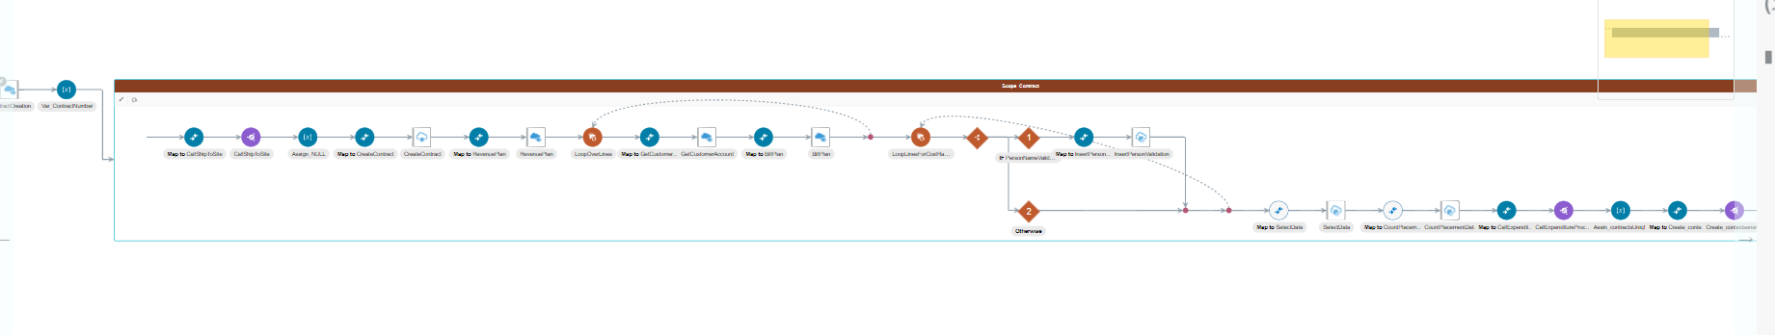

**XXCG Staffing Get Contract Expenditure Type** : This integration is used to create expenditure Type based on the Bill Rates provided in Payload and then it will load the data into ATP Table. From that table one more child integration will call to create costing.

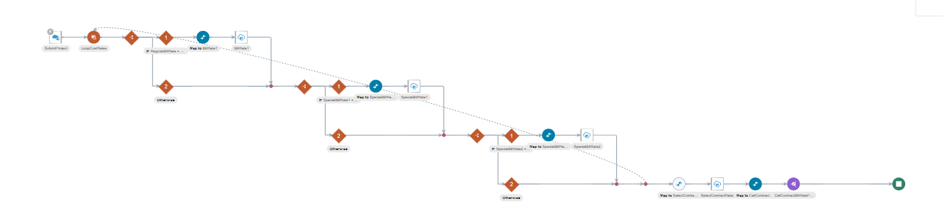

**XXCG Staffing Contract Bill Rates FBDI** : This integration is used to create contract costing from FBDI process



**XXCG Staffing context-sensitive DFFs :** This integration is calling when person is available and costing created then it will create context sensitive DFFs

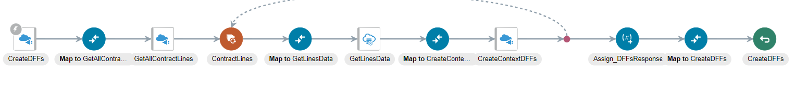

**XXCG Staffing Get Customer Sites:** This integration is used to fetch ship to site details based on theCustomer Name.

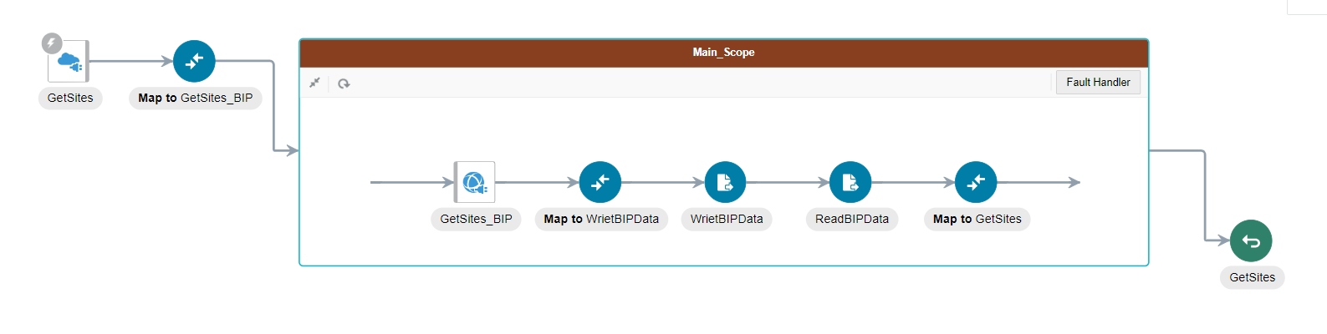

**XXCG Staffing Get PersonName:** This integration is used to get person names from SaaS to display it in VBCS Screen

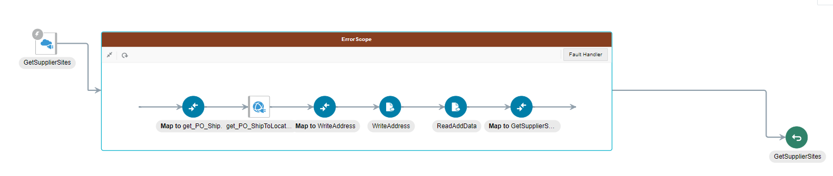

Below Are the ATP tables used in project and contract creation

XXCG STAFFING CONTRACT PLACEMENT

XXCG STAFFING PROJECT PLACEMENT

XXCG STAFFING PRJECT EXPENDITURE

ContractCostRates

# VBCS SCREEN FOR CWPS

**Overview**

* CWK Time card will be created into HCM-OTL and approved by Project Manager.
* Approved time card will be imported into Project Accounting cost .
* By using BIP report , we fetched the details of timecard and invoice details.
* By using integration we run the BIP report and generate the invoice.
* After invoice generation, VBCS application will show the timecard and invoice details.

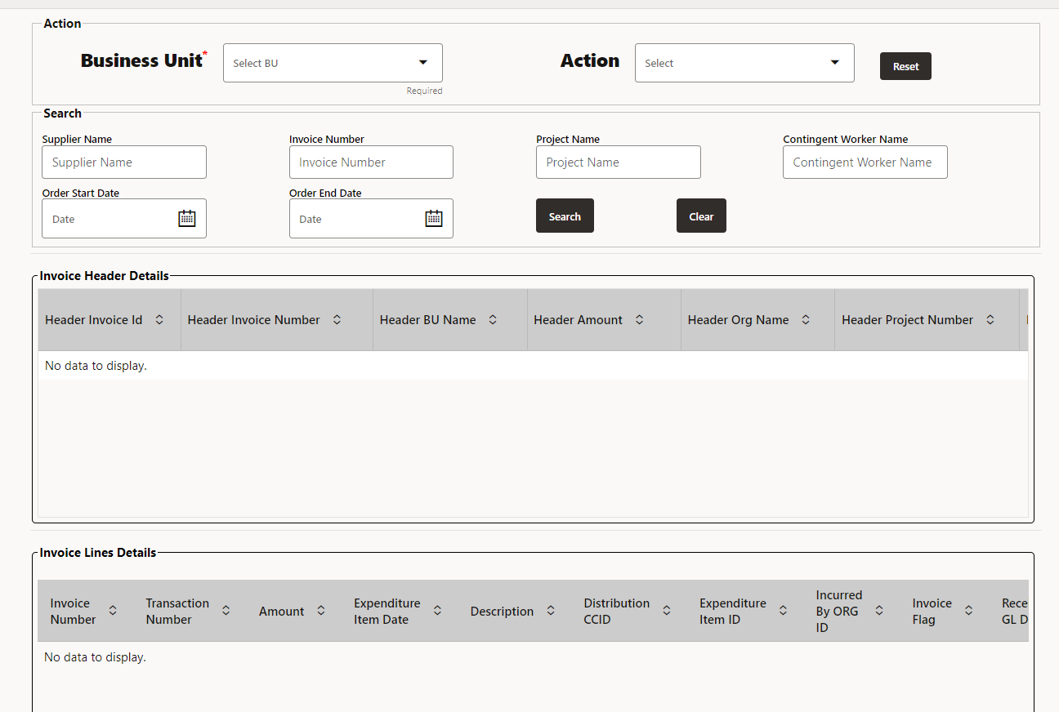

We develop this screen to create invoice and display data.

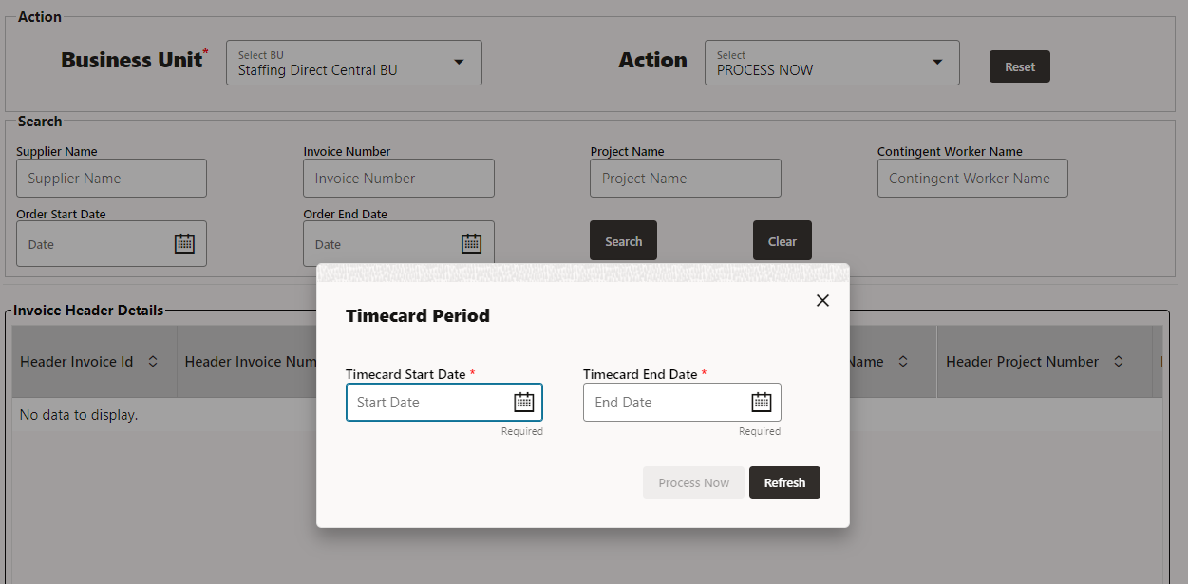

* Select Business Unit from drop down and select PROCESS NOW from Action drop down.
* After that Popup window will open. Provide timecard start Date and timecard End Date that is mandatory. Timecard start Date and Timecard End Date is the date for that invoice will be created, if timecard is approved for that date.
* If user enter same date again then invoice will not be created, it gives error ”Duplicate Dates cannot create invoice”.
* After giving Timecard start date and timecard end date click on Process Now button, then invoice will be generated.
* After that click on Refresh Button to load the data from ATP database to VBCS screen.

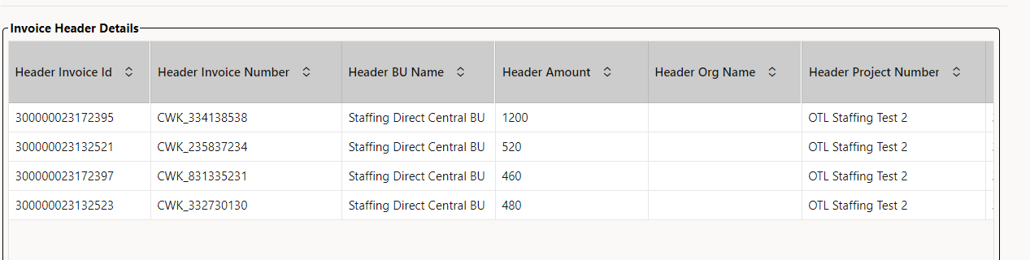

* Once the invoice is created successfully then the employee timecard information for which the invoice is created along with invoice number and other details are displayed on the Screen.
* Click on row of invoice header to get the Invoice lines detail related to invoice header details.

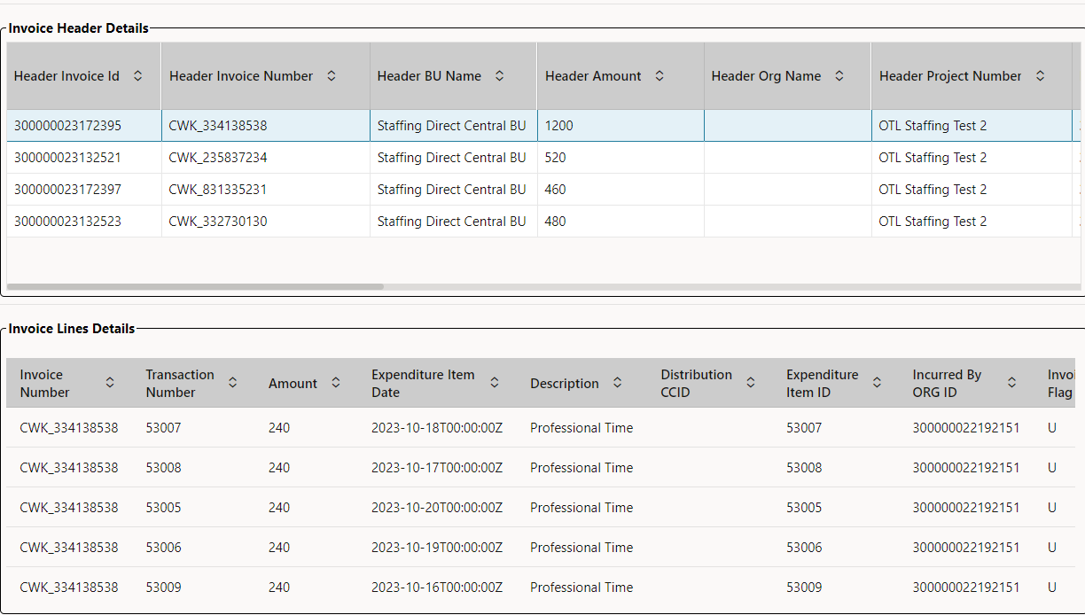

* Search page is capable of bring all employee and invoice details of contingent worker time card details.
* For Search the specific data provide the required input and click on **Search** button.

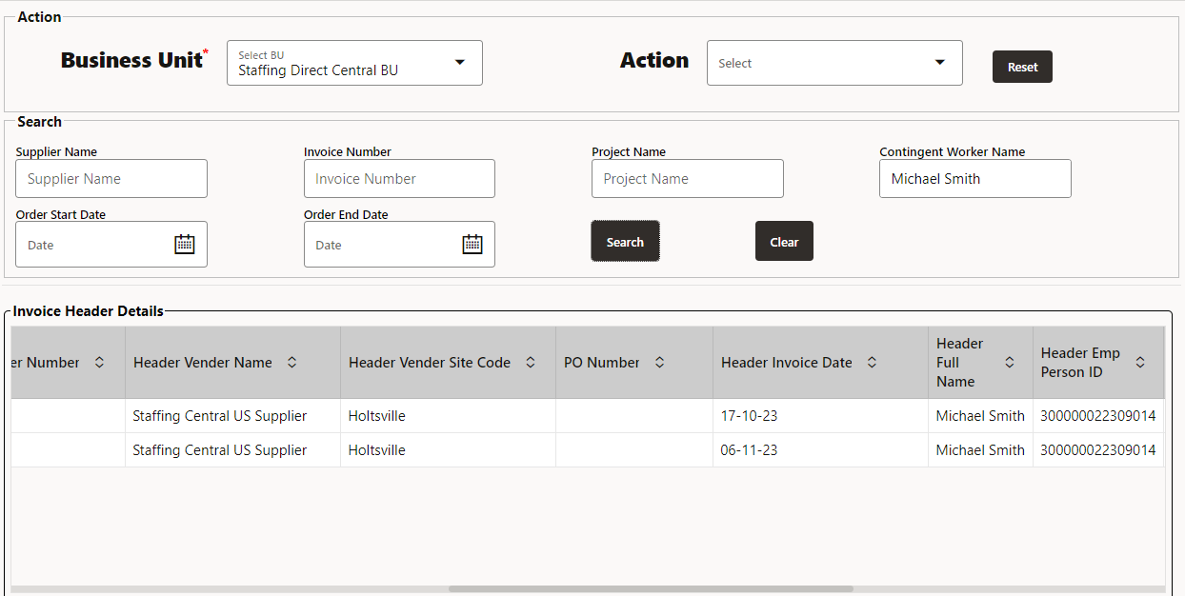

* We get the required data.

**GUI Column Details:**

* Business Unit: Business Unit in which the invoice is created
* Contingent Name: Contingent employee name
* Project Number: Project number where the contingent worker costs are incurred.
* Supplier Name: Supplier name for which the invoice is created
* Supplier Site: Supplier site details of the invoice
* Expenditure Type: Expenditure type of which the contingent worker cost is incurred (Eg : Professional Hours, Overtime etc.)
* Quantity: Quantity in Hours filled in timecard for the contingent worker
* Invoice Date: Date on which the Invoice is created
* Invoice Number: Invoice Number details
* Invoice Currency: Currency code for the invoice
* Invoice Amount: Cost amount incurred for contingent worker based on expenditure type and quantity
* Timecard Date: Date on which the timecard is entered for the contingent worker

Below Are the ATP tables used in Invoice creation:

XXCG_CWK_INVOICE_HEADER

XXCG_CWK_INVOICE_LINES

CHECK_VALIDATION_FLAG

# CWPS Invoice Creation Integration Process.

This document is to refer the Integration details which is used to create invoice out of BIP report from generated from SAAS and invoice is stored in the ATP and this Invoice information is displayed in VBCS Screen

## Invoice Creation Integration:

**CWPS_CONTINGENT_WORKERS_INVOICE_CREATION**:

This Integration is used to get invoice details using BIP reports from SaaS. The API generates the invoice and gets a invoice ID which then inserted into ATP table and these information is showcased in the VBCS screens using select query.

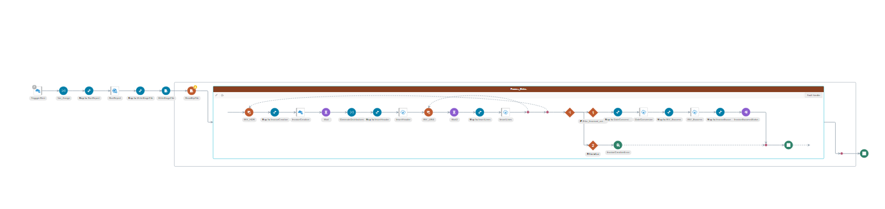

If the invoice is created, it will populate message “Invoice creation in progress. Please wait!!” once the invoice ID is generated the information will populate status in the ATP table” CHECK_VALIDATION_TABLE”, which VBCS Screens will populate using select query.

If the invoice is failed, it will populate the message “Invoice creation failed”.

ATP_TABLE:- XXCG_CWK_INVOICE_HEADER is used to store header information after invoice got created.

XXCG_CWK_INVOICE_LINES is used to store lines information after invoice got created.

**CWPS_BIP_REPORT_CHECKDATE:**

This Integration is used to check data for the provided dates.

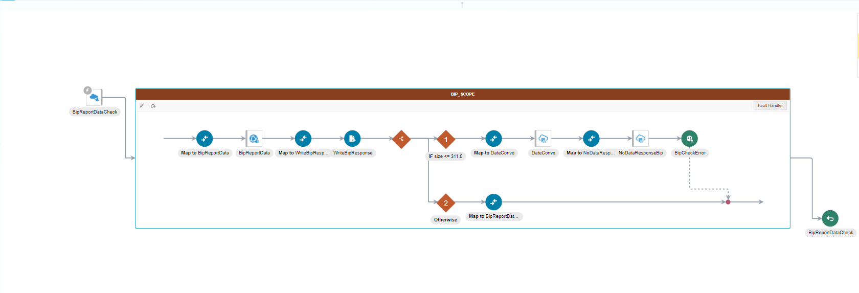

If there is no data present for the provided dates it will populate message “There is no data for the provided dates.”

**CWPS_CHECK_DUPLICATE_DATES:**

This Integration is used to check for duplicate dates.

If provided dates are duplicate, then it will populate message “Duplicate invoice can’t be created for the provided dates”.

ATP_TABLE: - CHECK_VALIDATION_TABLE is used to check the dates.

**CWPS_FUSION_INT_INVOICE_CREATION:**

This Integration is a fusion of **CWPS_BIP_REPORT_CHECKDATE** if validation is passed then it will call the **CWPS_CHECK_DUPLICATE_DATES** if the validation is passed then it will call the **CWPS_CONTINGENT_WORKERS_INVOICE_CREATION** and invoice created and stored in ATP tables.

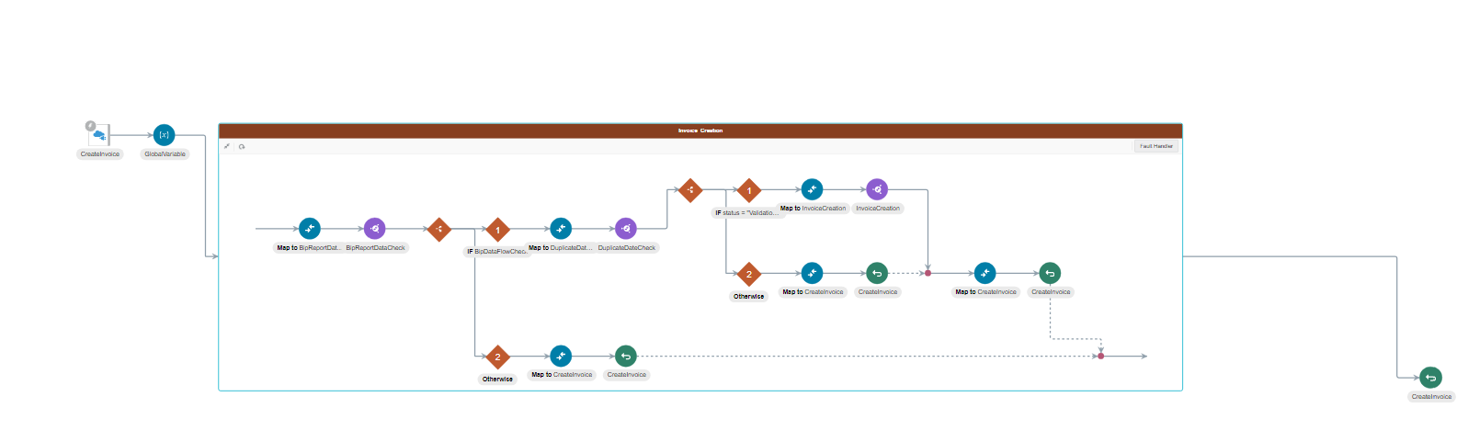

Below Are the ATP tables used in project and contract creation

XXCG_CWK_INVOICE_HEADER

XXCG_CWK_INVOICE_LINES

CHECK_VALIDATION_TABLE